**SQL Query Analysis**

**1.To import excel data into sql create table with column names and data types.**

CREATE TABLE DataAnalyst (

id INT PRIMARY KEY,

job_title TEXT,

salary_estimate TEXT,

job_description TEXT,

rating FLOAT,

company_name TEXT,

location TEXT,

headquarters TEXT,

size TEXT,

founded INT,

type_of_ownership TEXT,

industry TEXT,

sector TEXT,

revenue TEXT,

competitors TEXT,

easy_apply TEXT

);

**2./* View overall data all rows */**

SELECT*FROM DataAnalyst;

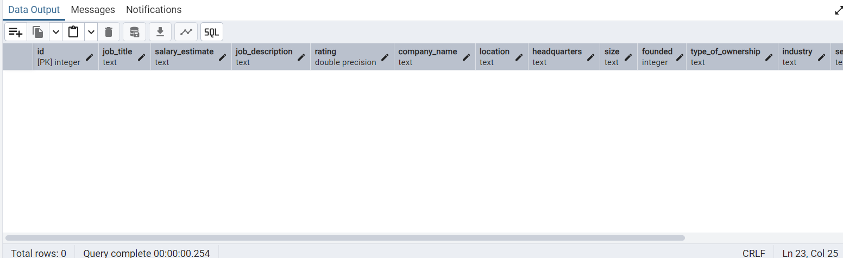

**3./* To import data from excel to sql */**

COPY DataAnalyst

FROM 'C:\Users\Sandhya\OneDrive\Desktop\Data Analyst Job Analysis\DataAnalyst.csv'

DELIMITER ','

CSV HEADER;

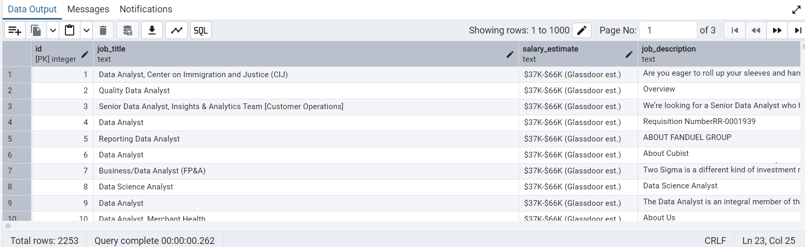

**4./*Top Job Locations by Count*/**

SELECT location, COUNT(*) AS job_count

FROM DataAnalyst

GROUP BY location

ORDER BY job_count DESC

LIMIT 20;

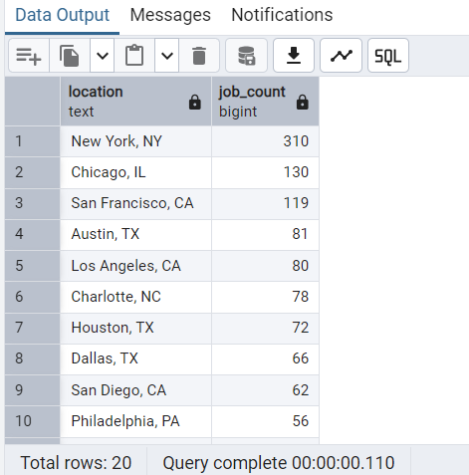

**5./*Company Size Distribution (excluding Unknown and '-1')*/**

SELECT size, COUNT(*) AS count

FROM DataAnalyst

WHERE size NOT IN ('-1', 'Unknown')

GROUP BY size

ORDER BY count DESC

LIMIT 20;

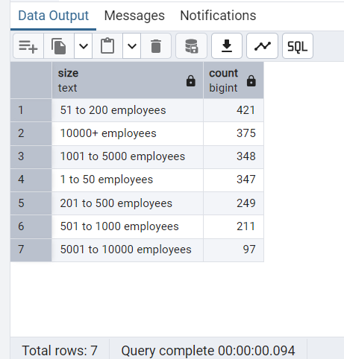

**6./*Top Sectors by Count (excluding '-1')*/**

SELECT sector, COUNT(*) AS count

FROM DataAnalyst

WHERE sector != '-1'

GROUP BY sector

ORDER BY count DESC

LIMIT 15;

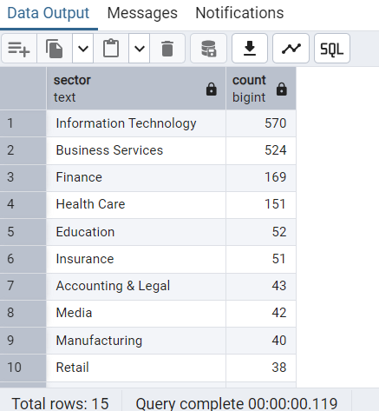

**7./*Top 10 Companies Posting the Most Data Analyst Jobs*/**

SELECT company_name, COUNT(*) AS job_count

FROM DataAnalyst

GROUP BY company_name

ORDER BY job_count DESC

LIMIT 10;

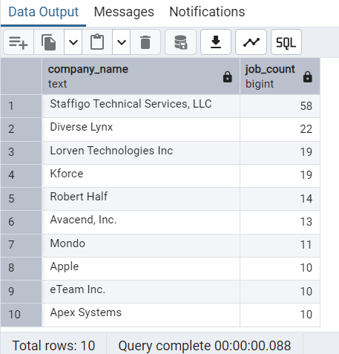

**8./* Average Company Rating by Sector*/**

SELECT sector, AVG(rating) AS average_rating

FROM DataAnalyst

WHERE sector != '-1' AND rating IS NOT NULL

GROUP BY sector

ORDER BY average_rating DESC;

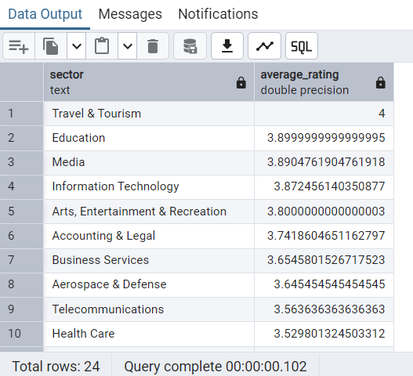

**9./*Count of Jobs by Type of Ownership*/**

SELECT type_of_ownership, COUNT(*) AS job_count

FROM DataAnalyst

GROUP BY type_of_ownership

ORDER BY job_count DESC;

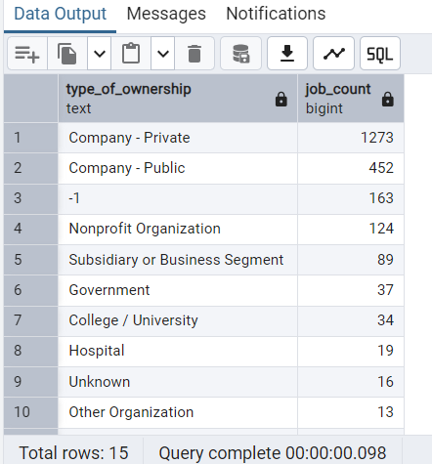

**10./*Top 10 Industries Hiring Data Analysts*/**

SELECT industry, COUNT(*) AS job_count

FROM DataAnalyst

WHERE industry != '-1'

GROUP BY industry

ORDER BY job_count DESC

LIMIT 10;

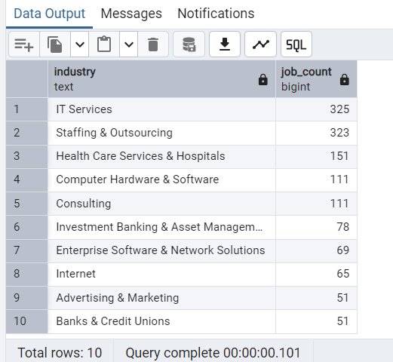

**11./*Top Headquarters Locations by Job Count*/**

SELECT headquarters, COUNT(*) AS job_count

FROM DataAnalyst

GROUP BY headquarters

ORDER BY job_count DESC

LIMIT 10;

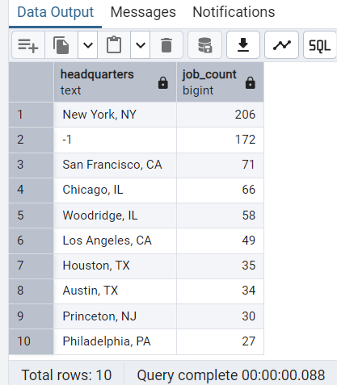

**12./*Job Postings by Year Founded*/**

SELECT founded, COUNT(*) AS job_count

FROM DataAnalyst

WHERE founded IS NOT NULL AND founded > 1800

GROUP BY founded

ORDER BY job_count DESC

LIMIT 20;

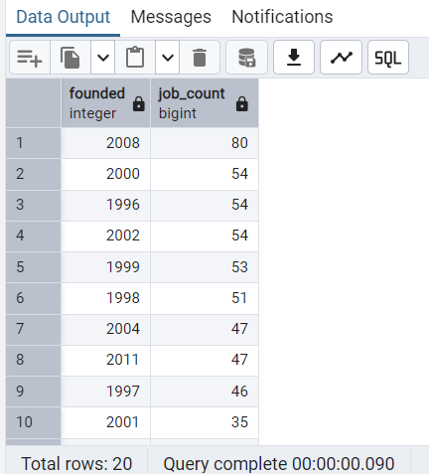

**13./*Top 10 Most Common Job Titles*/**

SELECT job_title, COUNT(*) AS job_count

FROM DataAnalyst

GROUP BY job_title

ORDER BY job_count DESC

LIMIT 10;

